Traffic Light Controller
FPGA Project Documentation
Verilog RTL Design & Verification

1. Introduction
This document describes the design and verification of a four-way traffic light controller implemented in Verilog. The system manages North-South and East-West traffic flows, displays a countdown timer on a two-digit seven-segment display, and supports two priority override modes: an emergency vehicle mode and an empty-road detection mode.

1.1 Objectives
- Implement a finite-state machine (FSM) that cycles the four traffic-light phases.
- Generate a slow internal clock from the board clock using a clock divider.
- Debounce a physical push-button used to request extra green time.
- Display a live countdown of the remaining time for the current phase on two seven-segment digits.
- Support two priority inputs (Emergency, Empty Road) that override the normal sequence.
- Verify the complete design with a self-checking testbench covering normal operation, the button, and both override modes.

2. System Architecture
The design is split into six modules, integrated under a single top-level module (Top). Figure 1 shows the module hierarchy and signal flow.
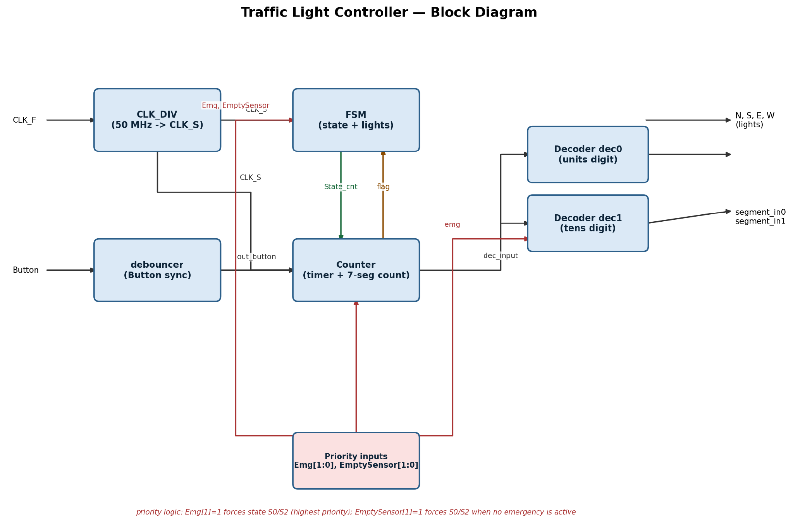
Figure 1 — Block diagram of the traffic light controller

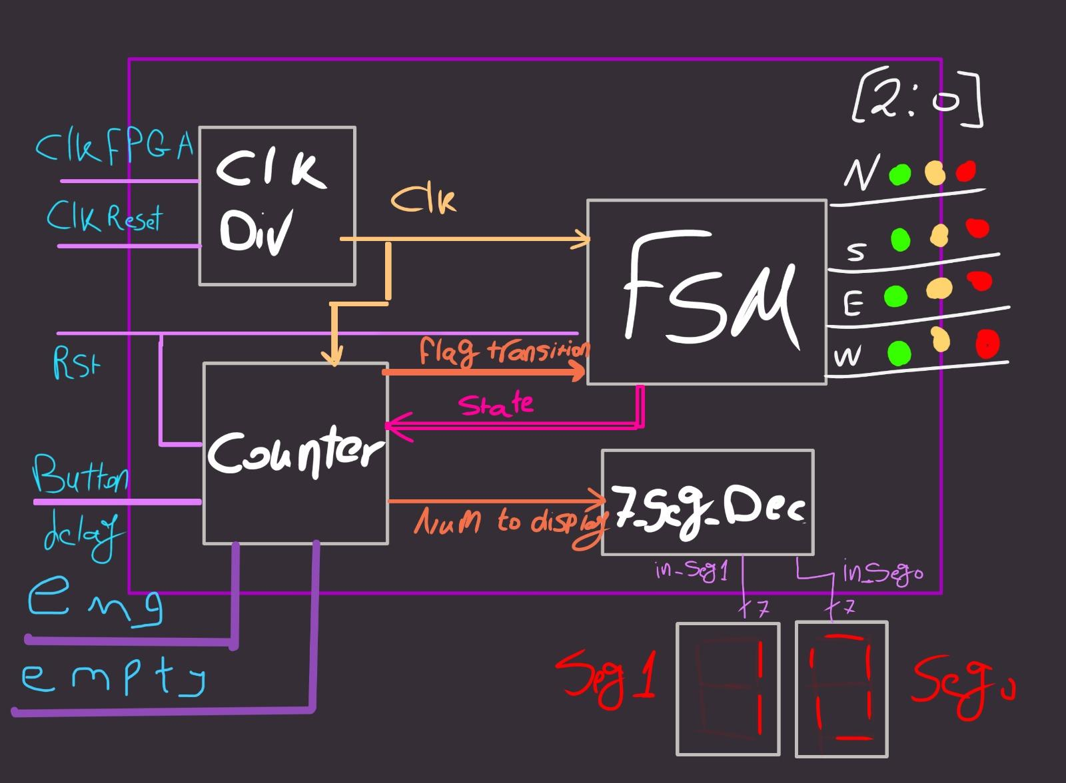
Handwritten diagram showing the main flow

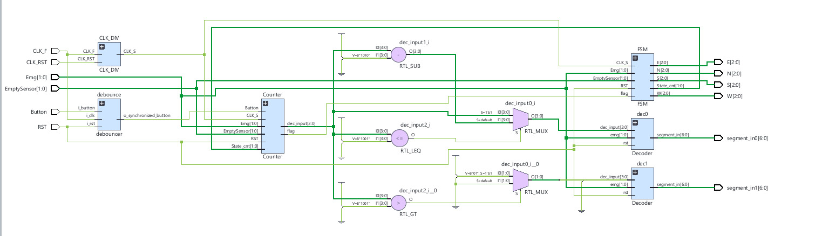
Schematic diagram of the traffic light controller on Vivado

2.1 Module List
- CLK_DIV — divides the board clock down to a slow clock (CLK_S) used by the FSM and Counter.
- debouncer — synchronizes and debounces the raw push-button input.
- Counter — tracks elapsed time per phase, decides when to advance the FSM (flag), and produces the value shown on the seven-segment display.
- FSM — holds the current traffic-light state and drives the N, S, E, W light outputs.
- Decoder — converts a 4-bit digit into 7-segment display segments (instantiated twice, for tens and units).
- Top — instantiates and wires all of the above into the complete system.

3. Module Descriptions

3.1 Clock Divider — CLK_DIV
Divides the fast board clock CLK_F down into a much slower clock CLK_S used by the rest of the design, by toggling CLK_S every 25 counts of CLK_F.
Port | Dir | Width | Description
CLK_F | in | 1 | Fast input clock
CLK_RST | in | 1 | Active-low asynchronous reset
CLK_S | out | 1 | Slow divided clock (toggles every 25 CLK_F cycles)

3.2 Debouncer — debouncer
Synchronizes the raw button input into the clock domain with a 2-stage synchronizer, then requires the synchronized level to stay stable for 500 clock cycles before accepting it as the new button state. This removes mechanical contact bounce from the physical push-button.
Port | Dir | Width | Description
i_clk | in | 1 | Sampling clock
i_rst | in | 1 | Active-low asynchronous reset
i_button | in | 1 | Raw, noisy button input
o_synchronized_button | out | 1 | Debounced, synchronized button level

3.3 Counter

Port | Dir | Width | Description
CLK_S | in | 1 | Slow clock
Button | in | 1 | Debounced button (extend-time request)
RST | in | 1 | Active-low asynchronous reset
Emg | in | 2 | Emergency priority input
EmptySensor | in | 2 | Empty-road priority input
State_cnt | in | 2 | Current FSM state (S0-S3)
flag | out | 1 | Asserted for one cycle when the phase timer expires
dec_input | out | 4 | Value driven to the seven-segment decoders

Counts clock cycles within the current FSM phase and asserts flag once the phase's target count is reached, telling the FSM to advance. The green phases (S0, S2) normally run for 10 counts, extended to 15 counts if the debounced button was pressed during that phase (button_ext). The yellow/clearing phases (S1, S3) always run for a fixed 3 counts. dec_input is derived from the remaining count so the seven-segment display counts down.Note: the target count for the green phases (maxo) is only re-evaluated on the same cycle the counter resets, using whatever button_ext was at that moment — so the button must be pressed during the running phase to extend it, not after.

3.4 FSM
Holds the current phase (S0-S3) and drives the four traffic-light outputs (N, S, E, W), each a one-hot 3-bit code representing RED / YELLOW / GREEN. Under normal operation the FSM advances S0 -> S1 -> S2 -> S3 -> S0 each time flag pulses. The two priority inputs can force an immediate jump to S0 or S2:
- Emg[1]=1: jump to S2 if Emg[0]=1, otherwise S0.
- EmptySensor[1]=1 (checked only when no emergency is active): jump to S2 if EmptySensor[0]=0, otherwise S0.
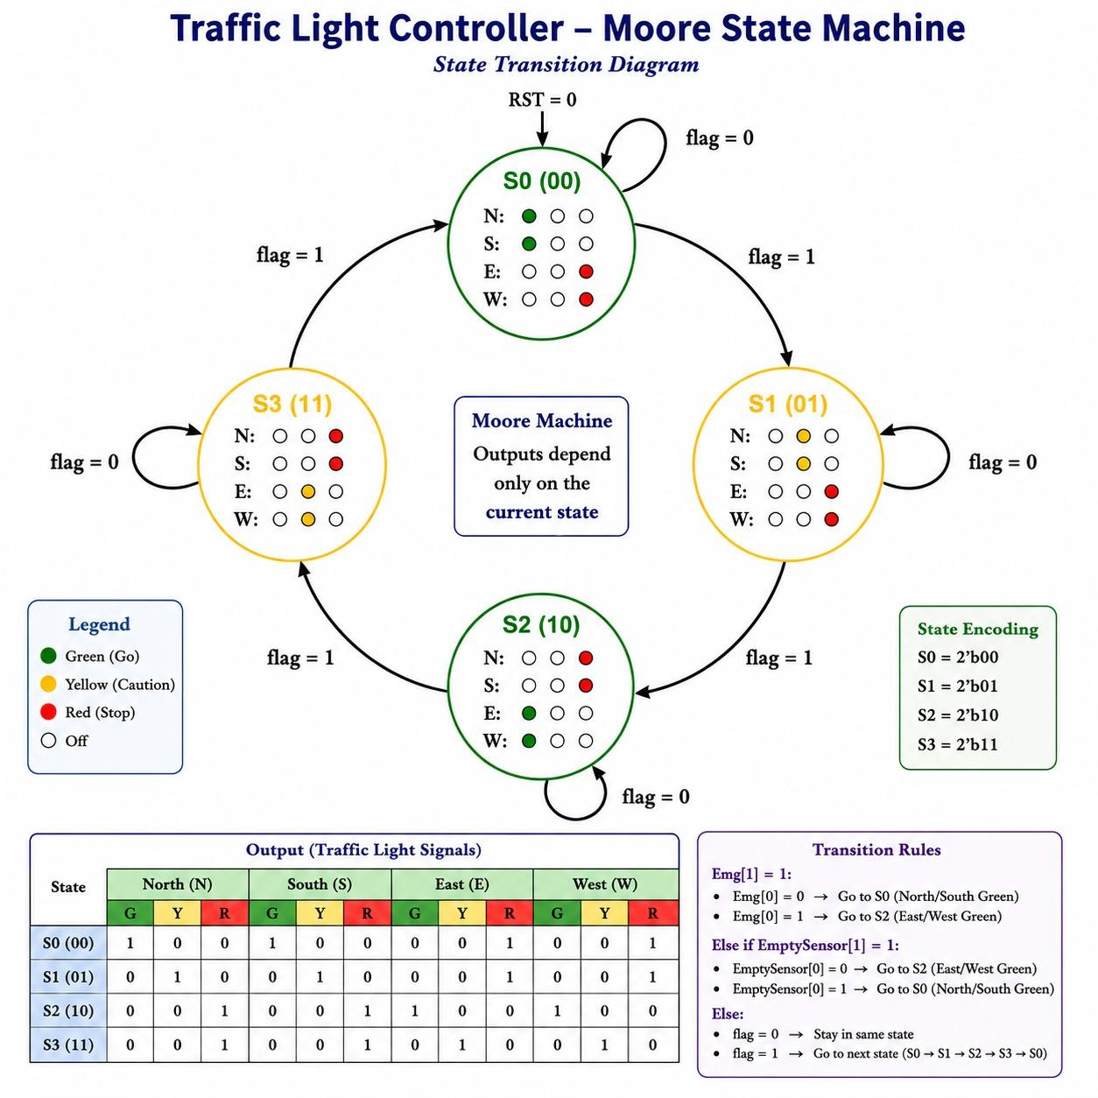
Figure 2 — FSM state diagram

State | N,S Lights | E,W Lights | Meaning
S0 | GREEN | RED | North-South road flows
S1 | YELLOW | RED | North-South clearing
S2 | RED | GREEN | East-West road flows
S3 | RED | YELLOW | East-West clearing

3.5 Seven-Segment Decoder

Port | Dir | Width | Description
CLK_S | in | 1 | Slow clock
RST | in | 1 | Active-low asynchronous reset
flag | in | 1 | Advance-state pulse from Counter
Emg | in | 2 | Emergency priority input
EmptySensor | in | 2 | Empty-road priority input
N, S, E, W | out | 3 each | One-hot light code per direction
State_cnt | out | 2 | Current state, fed back to Counter
Converts a 4-bit BCD digit into the 7 segment drive signals. When emg[1] is asserted, the display is forced to show 'E' regardless of the digit, to flag emergency mode at a glance. While rst is low, all segments are held off. Two instances are used in Top: one for the units digit and one for the tens digit.3.6 Top-Level Integration

Port | Dir | Width | Description
dec_input | in | 4 | BCD digit to display
rst | in | 1 | Active-low reset (segments blanked when low)
emg | in | 2 | Forces display to 'E' when emg[1]=1
segment_in | out | 7 | Seven-segment drive pattern (a-g)
Top instantiates CLK_DIV, debouncer, Counter, FSM, and two Decoder instances, and wires them exactly as shown in Figure 1. The raw dec_input value from Counter can range 0-15 across the two phase types, so Top splits it into a units digit and a tens digit before the decoders: dec0 receives dec_input directly when it is 9 or below, otherwise dec_input-10; dec1 receives a 1 only when dec_input is above 9, otherwise 0.

4. Verification
The design is verified with a self-checking testbench (dut_tb) that instantiates Top and drives it through four scenarios in sequence:
- Normal operation: reset released, then the FSM is allowed to free-run for 50 ms to observe multiple full S0->S1->S2->S3 cycles.
- Button extension: Button is held for 15 ms (longer than the 10 ms debounce window) to confirm the debouncer accepts it and the current green phase is extended.
- Empty-road override: EmptySensor is pulsed to confirm the FSM jumps directly to the opposite green phase.
- Emergency override: Emg is pulsed to confirm the same immediate-jump behavior, with highest priority over the empty-road input.
The board clock CLK_F is modeled at 50 kHz (20 µs period) in the testbench, matching the debouncer's design comment.

5. Conclusion
The controller implements a standard four-phase traffic sequence with debounced manual extension and two priority override paths, and produces a live countdown on a two-digit seven-segment display. The module boundaries (clocking, input conditioning, timing, state control, and display) are kept separate, which makes each block independently testable and reusable.

6. Results
If Emg[1] =1 , (emergency case)

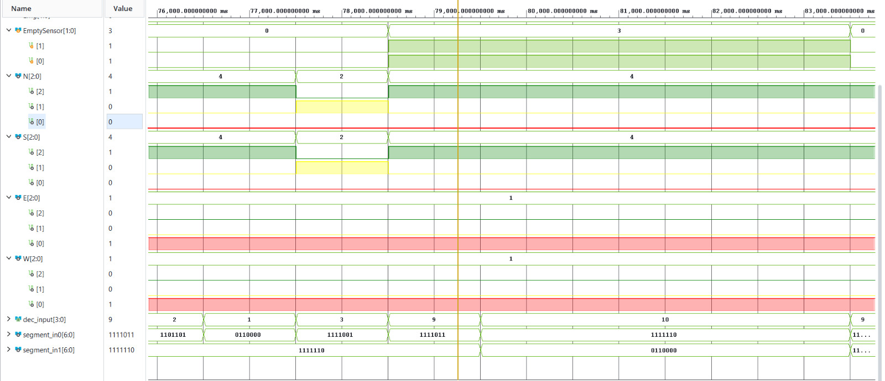

If empty_sensor[1] =1 , (empty road)

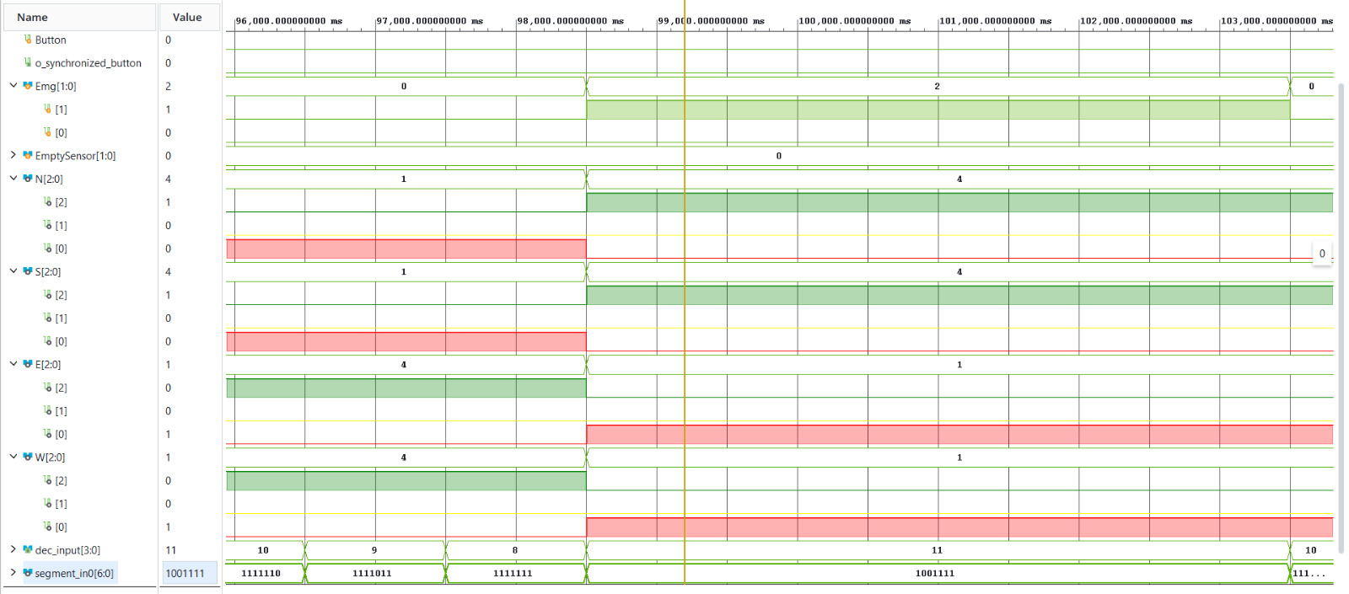

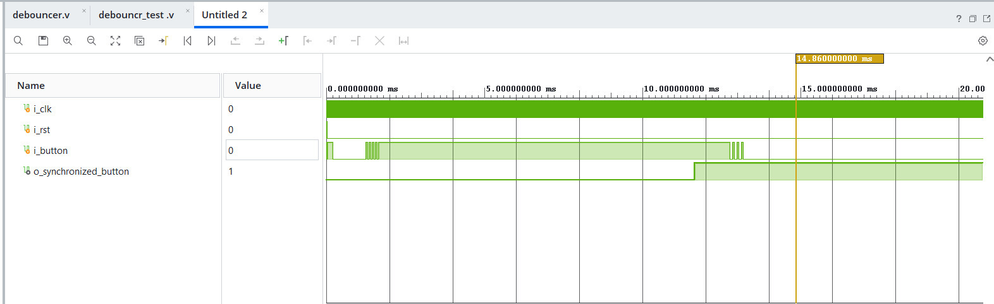
Debouncer simulation

